Name : Saood Ur Rahman
Roll No : 17P-6092
Section : “A”

Qustion # 1:

A)
Regular Experation:
a((a+b)*a)*
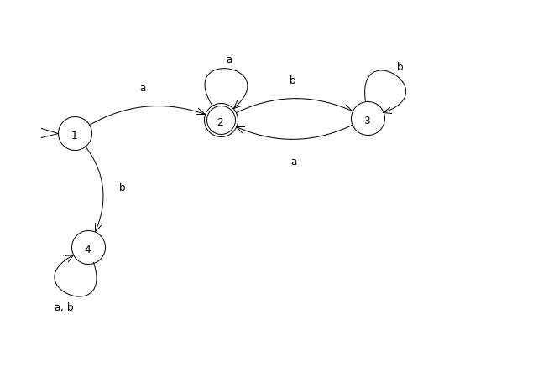

B)
Regular Experation:
(a+b)*aa(a+b)*
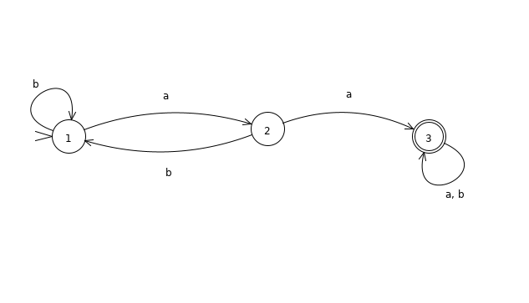
C)
Regular Experation:
(b*ab*ab*)
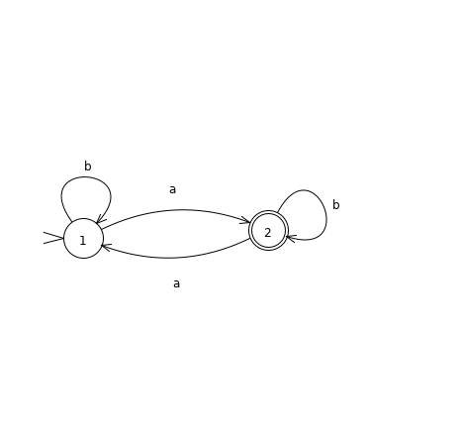

Qustion : 2

Part (A)
Does not contain bb

Regular Experation:
b*(baa*)*

DFA
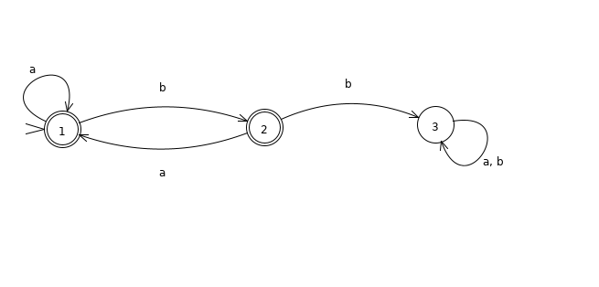

Part (B)
Does not contain baa

Regular Experation:
a*+a*bb*(abb*)*+a*bb*(abb*)*b
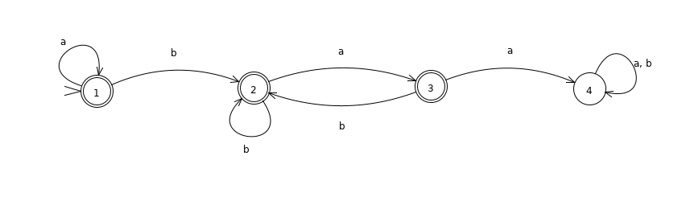

Part (C)
Does not contain aaa

Regular Experation
b*(abb*)*(aabb*(abb*)*)*(a+aa)
